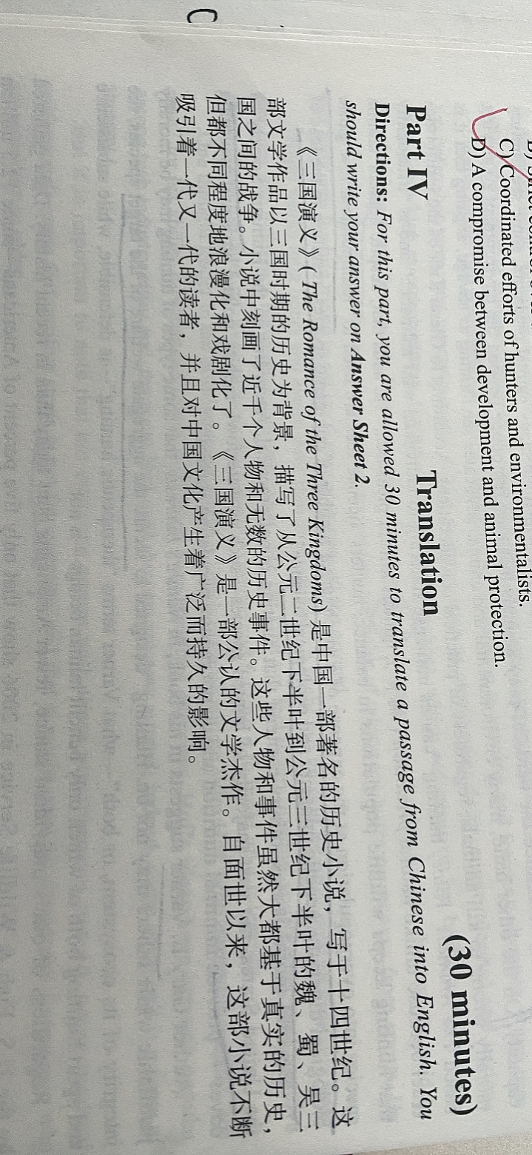The Romance of the Tree Kingdoms, written in the 14th century, is a famous historical novel in China. Set on(in) the history of the three kingdoms dynasty(period), this literary composition describes(depicts) the war between(among) three kingdoms, Wei, Shu and Wu, between the late (second half of the )2nd century(AD) and the late 3rd century. In the novel, thousands of characters and countless historical events are described. Although most of these characters and events are based on the true(real) history, they are dramatized and beautified(romanticized) to different extent. The Romance of the Three Kingdoms enjoys the fame of a great literature composition. Since born, it has continuously appealed to readers from different generations, and has had wide and permanent(lasting) influence on Chinese culture.